
UNIVERSITI TUNKU ABDUL RAHMAN ( UTAR )
LEE KONG CHIAN FACULTY OF ENGINEERING AND SCIENCE
MAY 2016 TRIMESTER

UECS2103 OPERATING SYSTEMS

Lecturer: Mr.Sor Kean Vee
NAME | ID
SHEH CHUN MING | 1403337
CHOO CHEN WEI | 1503784

Part A (1)
semaphore emptyPiles = 0, emptyFuels = 0, drillingPiles = 0, Fuels = 0, fillPiles = 0, fillFuels = 0;
bool found = false;

void main()
{
parbegin (Workers, PileSupplier, FuelSupplier);
}

Workers()
{
int x;
do{
Display “Resources Empty, Requesting for refill”;
semSignal(emptyPiles);
semSignal(emptyFuels);
x=1;
do{
for(int y=0;y<2;y++)
semWait(drillingPiles);
for(int z=0;z<4;z++)
semWait(Fuels);
found = (isFound()== 5);
if(!found)
Display “Mineral Not Found”;
else
Display”Mineral Found!”;
x++;
}while(!found && x<=6);
}while(!found);
pthread_exit();
}
PileSupplier()
{
do{
int i=0;
Display “Filling Piles”;
semWait(emptyPiles);
while(i<12){
semSignal(drillingPiles);
i++;
}
semSignal(fillPiles);
Display “12 Piles are ready”;
}while(!found);
pthread_exit();
}

FuelSupplier()
{
do{
int i=0;
semWait(emptyFuels);
Display “Filling Fuels”;
while(i<12){
semSignal(Fuels);
i++;
}
Display “24 fuels units are ready”;
semSignal(fillFuels);
}while(!found);
pthread_exit();
}

Part A (2)
Print Screen of Result

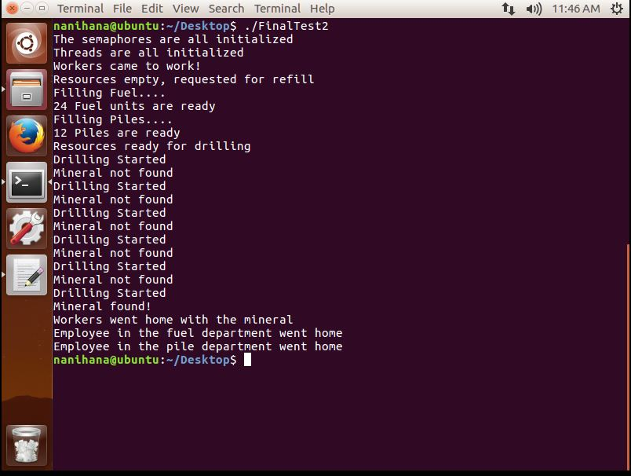

Part B
- Power Management System
Functionality:
The function of a power management system is to make sure that the electrical system is safe and efficient. If the power consumption is larger than the power production capacity, load shedding is used to avoid power outages.

Type of Real-Time Task : Soft.

Consequence of failing before deadline :
Insufficient power to be directed to the residents and cause widespread blackout.

- Security System
Functionality:
The function of a security system is to capture the face of people who enters the building and analyses it. An alert will be sent to the security department if a blacklisted or wanted or suspicious personnel is detected.

Type of Real-Time Task: Soft

Consequence of failing before deadline :
Suspicious personnel failed to be detected.

- Smoke and Fire Detecting System
Functionality:
The function of a smoke and fire detecting system is to sense smoke as an indicator of fire. If smoke is detected in the building, it will provide audible or visual alarm to signal the residents there is a fire breaking out, and access the fire sprinkler system to put out the fire. Also, the system will send an alarm to the fire department.

Type of Real-Time Task: Hard

Consequence of failing before deadline:
Residents in the building might get critical injury or even facing death. The whole building might be consumed by the fire.

